**Cultural Life of Saratov Region**

**Reference book**

*Saratov is one of most important cultural centers in Russia. It is famous for its galleries, museums and exhibitions. Saratov is a native city of many famous artists. People of our city made a great contribution to the cultural development of our country. This reference book will help the guests of the city to learn about some aspects of the cultural life of Saratov and its region.*

**Aa – Art Saratov. Festival of modern art in Saratov**

From 2013 in our city the Festival of modern art «art-Saratov» is organized. This project is developed by the Radishchev State Art Museum and the Saratov regional public organization «Union of artists of Russia». The main purpose of the Festival is to attract attention of authorities and citizens to the creativity of the true masters of art - those who Saratov can be proud of.

The festival demonstrates the Saratov art in all its forms, from the beginning to the present. Viewers can learn about paintings and graphics, sculpture and decorative and applied arts, photography and video art, performance and features. The works presented at the first festival were created in XIX-XX centuries by the classics of the Saratov art - Viktor Borisov-Musatov, Pavel Kuznetsov, Peter Utkin, Kuzma Petrov-Vodkin and Alexander Matveev. During the second Festival ( summer 2014) creative meetings and master classes of the leading Saratov painters, sculptors, theatre artists and animators will be held. People will observe the process of creating works of art, see «creative cuisine» artists, discover the mysteries of magic creativity.

**Bb – Borisov-Musatov Victor Borisov-Musatov**

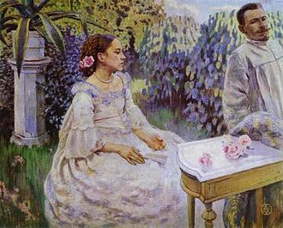 Self-Portrait with sister, 1898

Victor Elpidiforovich Borisov-Musatov ( 1870 - 1905) was a Russian painter, prominent for his unique Post-Impressionistic style that mixed Symbolism, pure decorative style and realism. Together with Mikhail Vrubel he is often referred as the creator of Russian Symbolism style.

Victor Musatov was born in Saratov. In his childhood he suffered a spinal injury, which made him humpbacked for the rest of his life. In 1884 he entered Saratov real school, where his talents as an artist were discovered by his teachers Fedor Vasiliev and Konovalov.

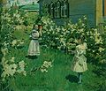 May Flowers, 1894

He was enrolled in the Moscow School of Painting, Sculpture and Architecture in 1890, transferring the next year to the Imperial Academy of Arts in Saint-Petersburg, where he was a pupil of Pavel Chistyakov. The damp climate of Saint-Petersburg was not good for Victor's health and in 1893 he was forced to return to Moscow and re-enroll to the Moscow School of painting, sculpturing and architecture. His earlier works like “May flowers”, 1894 were labelled decadent by the school administration, who sharply criticised him for making no distinction between the girls and the apple trees in his quest for a decorative effect. The same works however were praised by his peers, who considered him to be the leader of the new art movement.

In 1895 Victor left Moscow School of painting, sculpturing and architecture and enrolled in Fernand Cormon's school in Paris. He studied there for three years, returning in summer months to Saratov. He was fascinated by the art of his French contemporaries, and especially by the paintings of "the father of French Symbolism" Pierre Puvis de Chavannes and by the work of Berthe Morisot.

Borisov-Musatov was a member of the Union of Russian Artists and one of the founders and the leader of the Moscow Association of Artists, a progressive artistic organization that brought together Pavel Kuznetsov, Peter Utkin, Alexander Matveyev, Martiros Saryan, Nikolai Sapunov, and Sergei Sudeikin.

Another famous painting is “The Phantoms”..

In 1904 Borisov-Musatov had a very successful solo exhibition in a number of cities in Germany, and in the spring of 1905 he exhibited with Salon de la Société des Artistes Français and became a member of this society.

The last finished painting of Borisov-Musatov was “Requiem”. Devoted to the memory of Nadezhda Staniukovich, a close friend of the artist, the painting may indicate Borisov-Musatov's evolution towards the Neo-classical style.

**Cc – The Chernishevskiy Museum**

The Chernishevskiy Museum was established in 1920 by the younger son of a famous writer. He handed over to the nation the most precious collection of manuscripts, documents, photos, books and individual possessions of his father. The museum operates as a social and educational establishment.

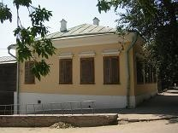

The museum organizes exhibition of famous Russian and modern artists lectures for students. In February 2014 there will be the exhibition devoted to the famous Russian painter V. Fomichev “Sochi landscapes”.

Official site: http://sarusadba.seun.ru/

**Dd- DILETTANTISM** –

DILETTANTISM is non-professional, amateur attitude to art.

A dilettante is a person who is interested in art and goes in for art for pleasure, entertainment, he doesn’t have has any special training. Dilettante believes that the meaning of fine arts is in the image of objects and the surrounding reality. In England in 1732 was founded the "Society of Amateurs - aristocratic club of collectors and art lovers. Representatives of DILETTANTISM in Saratov are S. Grishin, N. Rossov, Sheve, Bakunov,

**Ee** - **Exter Alexandra** (1882 -1949)

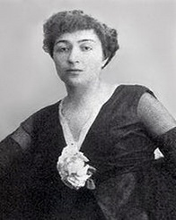 Alexandra Exter the suprematist and constructivist painter, designer, and co-founder of the Art Deco movement, was born on January 6, 1882 in Belostock. In 1907, she studied at the Kiev art school, then at the Académie de la Grande Chaumière in Montparnasse, Paris. From 1908 to 1924, Exter lived in Kiev, St. Petersburg, Odessa, Paris, Rome, and Moscow.

In 1914, Alexandra Exter presented at the Salon des Indépendants in Paris and at the International Futurist Exhibit in Milan with Kasimir Malevich, Alexander Archipenko, Vadym Meller, Sonia Delaunay-Terk. Exter joined the avant-garde group "Supremus" in 1915. Three years later she founded a teaching and production studio in Kiev, in which artists such as Meller, Petrytsky, Redko, Chelitschev, Shifrin und Nikritin contributed. Moreover, Alexandra Exter worked as a costume designer until 1920. Some Exter’s works are in the Radishchev Art Museum.

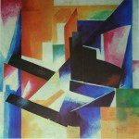 "Цветовая конструкция" 1921. The Radishchev Art Museum.

Alexandra Exter was active as an illustrator until her death on March 17, 1949.

**Ff – The Fedin Museum** (**The State Fedin Museum)**

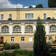 The State Fedin Museum was opened in 1981 in Saratov, in the native town of the writer. The building of a Museum is a monument of architecture of the XVIII century. In the end of XIX century, it was the Sretenskoe monastery primary school, where K.A. Fedin studied in 1899-1901 years.The museum is known as the museum of Russian literature of the 20th century. There are unique materials on the history of Russian and foreign literature of the XIX-XX centuries in it. A special pride of the Museum is a collection of autographs of great Russian writers of the XIX century: Gogol, Turgenev, Dostoevsky, Saltykov-Schedrin, Chekhov, Nekrasov. The museum contains works of famous painters: N.Kuzmin, K. Petrov-Vodkin, T, Mavrina, D.Burlyuk and others. Very often exhibitions of modern Russian artists are organized in the Fedin Museum.

Address: 154, Chernyshevski Street ,Saratov, Russia Saratov

Official site: www.fedinmuseum.ru/

**Gg – Genres of art**

Paintings are traditionally divided into five categories or 'genres'. The establishment of these genres and their relative status in relation to one other, stems from the philosophy of arts promoted by the great European Academies of Fine Art, like the the Accademia di San Luca in Rome, Accademia dell'Arte del Disegno in Florence, the Royal Academy in London, and the French Académie des Beaux-Arts. The five types of fine art painting, listed in order of their official ranking or importance, are as follows:

1. History Painting (works with message or moralistic content)

2. Portraits (individual, group or self-portraits)

3. Genre-painting (everyday scenes)

4. Landscapes

5. Still Life

All these genres are in art of Saratov.

**Hh – “The Hermitage Of The Volga Region»**

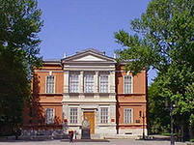

The Radishchev State Art Museum in Saratov is called “the Hermitage Of The Volga Region”. It is one of Russia’s oldest museums. It was established by Alexander Radishchev’s grandson, the famous painter Alexei Bogolyubov, who gave his collection of art works to the city. The building of the gallery (architect: Ivan Shtrom) was constructed from 1883 to 1885 on money from the municipal treasury and donations from citizens. The grand opening of the Radishchev Museum was held on June 29, 1885.

The first collection consisted of works by Bogolyubov, Ilya Repin, Vasily Polenov, Fyodor Bronnikov and Konstantin Savitsky, as well as masters of Western Europe: Jean-Baptiste Corot, Charles-Francois Daubigny and Adolphe Monticelli. In 1897 the museum became a home of Bogolyubov’s drawing school.

The museum’s treasure grew thanks to gifts from the Hermitage, the Academy of Fine Arts and many other philanthropists, including the Tretyakov brothers and the sculptor Mark Antokolsky.

Now the museum’s collection includes more than 25,000 works of art such as icons and other religious items, 17th- to 20th-century sculpture and drawings from Russia and abroad, rare books and applied art. The pride of the collection are paintings of outstanding artists of the Russian painting school  Dmitry Levitsky, Karl Bryullov, Alexei Savrasov, Vasily Surikov, Ivan Levitan, Valentin Serov, Konstantin Korovin, Viktor Borisov-Musatov, Pavel Kuznetsov and Kuzma Petrov-Vodkin.— Dmitry Levitsky, Karl Bryullov, Alexei Savrasov, Vasily Surikov, Ivan Levitan, Valentin Serov, Konstantin Korovin, Viktor Borisov-Musatov, Pavel Kuznetsov and Kuzma Petrov-Vodkin. The museum has a number of branches: the Balakovskaya Art Gallery, the Kuzma Petrov-Vodkin Memorial Museum (Khvalynsk), the Mylnikov Picture Gallery (Engels) and the memorial museums at the homes of Borisov-Musatov and Kuznetsov.

Contacts: 39, Radishchev Street Saratov

Oficial site: http://radmuseumart.ru

**Ii – Leo Igorev** was a famous Russian painter. He was born in Saratov region in 1893. He was interested in art. In 1850 Igorev received a title of the artist's of Academy for the portrait of the farmer, and in 1854 he was awarded the title of the academician. He became the first academician of Saratov province! He worked on Church orders: he painted churches in Kostroma, Nizhny Novgorod and Vologda, wrote the icons for the Cathedral of Peter and Paul in Sestroretsk , and continued to work in the field of portrait painting. Leo Stepanovich often visited Saratov where his relatives lived. In 1885 he painted the Church in Saratov. In the autobiographical book he wrote that art in his soul «was higher than every other passion». He died in Saratov in 1893.

**Kk - Kuznetsov Pavel Varfolomeevich**

Kuznetsov Pavel Varfolomeevich (1878–1968) was a Russian painter and graphic artist. 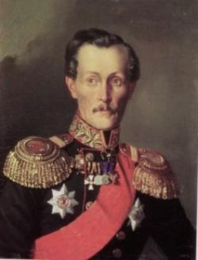

He studied at Saratov at Bogolyubov Art School (1891-1896) His early paintings were exhibited by the “Mir Iskusstva” group, and he was closely associated with the Russian Symbolists. He helped to organize the famous “Crimson Rose” exhibition (1904) and was a founder and a leader of “Blue Rose” in 1907. He taught at the Stroganov Institute and at the Moscow Institute of Fine Arts.

Kuznetsov's early paintings are typical of Blue Rose group's poetic explorations of an interior, imaginative world through archetypal symbols. After 1910 he drew increasingly on folk culture, continuing to draw on the rich colours and harmonious rhythms of the Symbolists. 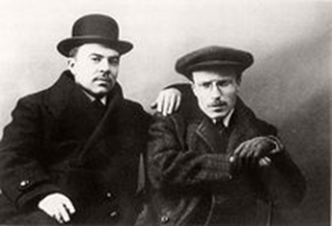 Pavel Kuznetsov and Alexander Matveyev.

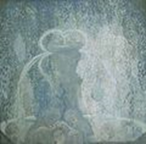 Blue Fountain, 1905

Famous works by Pavel Kuznetsov

In the steppes. Mirage, 1911

Still life with a Japanese Engraving, 1912

Harvesting of Fruits, 1913-1914

**Ll- Levitzky Dmitry (May 1735 – 17 April 1822)**

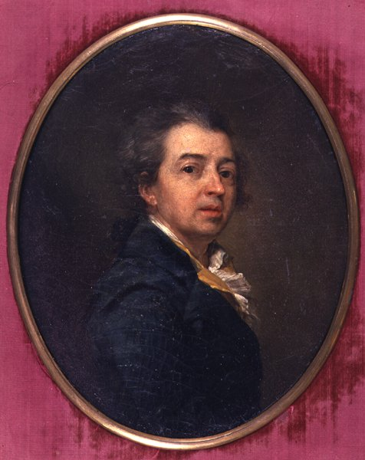 selfportrait

Levitzky Dmitry was born in Kiev, Russian Empire, in a family of clergyman and engraver Grigory Levitzky. His father was his first art teacher. Later be became a pupil of Aleksey Antropov who came to Kiev to paint the Cathedral of St. Andrew.

In 1770, Levitzky became famous as a portrait painter after the exhibition of six of his portraits in the Imperial Academy of Arts in St. Petersburg. For the portrait of Alexander Kokorinov, Director and First Rector of the Academy of Arts in St. Petersburg (1769) he was elected an academician and appointed the Professor of the portrait painting class at the Academy of Arts.

Architect Alexander Kokorinov, Director and First Rector of the Imperial Academy of Arts, 1769

He is famous for his portraits of Prokofiy Demidov. 1773, E. N. Khruschova and Princess E. N. Khovanskaya. 1773., Ekaterina Nelidova, 1773. Alexander Lanskoy, Aide-de-camp to the Empress, 1782 and others. At the present, the Radishchev museum’s collection includes some works by Levitzky Dmitry.

**Ll -** **The Local Lore Museum of Saratov** (The Saratov Regional Local Lore Museum )

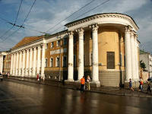 Saratov Regional f Local Lore Museum is one of the oldest museums in our region. The museum fund includes about 400 thousand items: extensive archaeological, ethnographical, hand-written books, documents, religious items, posters, paintings, materials on the history, social and cultural settings of our region. The diverse nature and history of the region from the ancient times to the present is represented here. Art exhibitions are demonstrated regularly. The famous exhibitions of the museums are:

-The exhibition of paintings of ELENA Slyshchenko «On the streets of old Saratov».

-The exhibition «Saratov by eyes of an artist» from the cycle «Saratov province features». The exhibition presents more than 40 works: paintings, graphics, sculpture, decorative and applied art. The project involves 22 Saratov artists.

Contacts:34, Lermontov Street Saratov

Official site: <http://www.comk.ru/>

**M m - Marina Milavina**

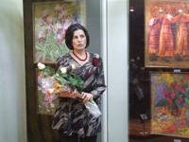 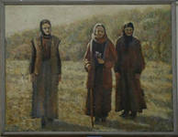“Vera, Nadezhda, Lyubov”

In March 2013 the exhibition “In the world of colors and flowers” by Marina Milavina was opened in the Saratov Regional Local Lore Museum.

The main place is occupied by the paintings of flowers - garden, fields ones and a lot of bouquets. Floral fantasy of Marina is shown in her works. Flowers for her is joy, delight, admiration. She uses oil, pastel, watercolors in her works. The picture “Vera, Nadezhda, Lyubov” attracts the visitors of the exhibition most of all. Marina Milavina is a master of women’s portraits too. Marina Yurievna Milavina was born in Saratov. In 1975 she was graduated from the artistic and pedagogical faculty of the Saratov art College. Her teachers were V. Danilov, P. Grishin, Yu. Kolchin. Works by Milavina are represented in the exhibitions of museums of Saratov region. She is the author of several personal exhibitions.

**N n - Night of museums" in Saratov**

Saratov took part in the international campaign «Night of museums». For the first time such action was held in our city 2006, by the Saratov regional local lore Museum and the Radishchev Art Museum. In 2014 «Night of museums» will be held by the Kuznetsov Museum, the Fedin Museum, the Regional Local Lore Museum, the Radishchev State Art Museum. This year the programme of «Night of museums» will include: the exhibition of the works by the students of Saratov Art School “Kolibri» ;

-exhibitions “Masterpieces of the collection of the Radishchev Museum», «Dialogue with the city».

-outdoor exhibition-action; open workshops at the Kuznetsov Museum («Trash-art for everyone» - a master class by Alexander Gnutov, «Moebius Strip» -an interactive art object by Nicholas Arzhanova, «Dream catcher» - Interactive installation and master-show by Andrei Golubtsov);

- graffiti workshop and so on

**O o- an outdoor exhibition**

Outdoor exhibition is an exhibition which is held in the open air. Outdoor exhibitions as a rule are held in Saratov during the action «Night of museums» by the Fedin Museum and the Kuznetsov Museum in spring, summer or autumn.

**Pp- Petrov-Vodkin Kuzma Sergeevich**

Petrov-Vodkin Kuzma Sergeevich (1878 – February 15, 1939) was an important Russian and Soviet painter and writer. 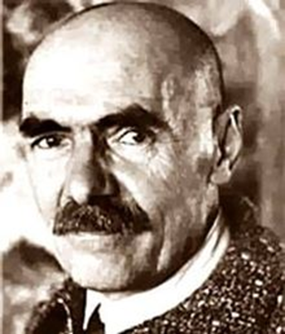

Kuzma Petrov-Vodkin was born in Khvalynsk (Saratov Oblast) into the family of a local shoemaker. His first exposure to art was in his early childhood, when he took some lessons from a couple of icon painters and a signmaker. Still, Petrov-Vodkin didn't quite see himself in art at that time; after graduating from middle school, he took a summer job at a small shipyard with plans to get into railroad college in Samara. After failing his exam, he turned to "Art Classes of Fedor Burov" in 1893.

Petrov-Vodkin took different painting jobs in the vicinity of Saratov. Petrov-Vodkin got an invitation to study art at Saint Petersburg where he met Borisov-Musatov, an important painter resident in Saratov, who encouraged Petrov-Vodkin to continue his studies.

From 1895 to 1897 Petrov-Vodkin studied at the Baron Stieglits School, later at the Moscow School of Painting, Sculpture and Architecture. There Petrov-Vodkin was a student of Valentin Serov, Isaak Levitan and Konstantin Korovin.

Some of his early works were too erotic that was why he had a conflict with the Russian Church. His first well-known work was “The Dream” (1910). “Bathing of a Red Horse” his most iconic work became an instant classic, and, in a sense, trademark for the artist. He used bright colours and unusual compositions in his works.

From 1924 to 1926 Petrov-Vodkin lived in France with his family. In 1922 he painted a portrait of the Russian poet Anna Akhmatova.

Petrov-Vodkin developed his "spherical perspective": a unique twist that distorted the drawing as to represent the viewer high enough to actually notice the spherical curve of the globe.

With help from the government, he made several trips across the country, producing many works with didactic purposes.

In February 1939, Petrov-Vodkin died of tuberculosis in Leningrad.

The largest collection of Petrov-Vodkin's works is in the Russian Museum in St Petersburg, where, as of 2012, a whole room in the permanent exhibition is devoted to the painter. In Khvalynsk, his native town there is a museum of the painter.

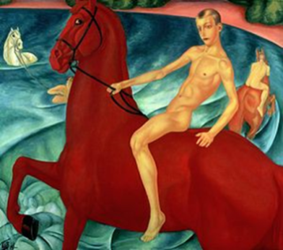 The iconic work of Petrov-Vodkin - "Bathing of a Red Horse".

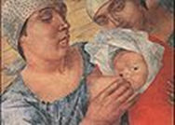 Motherhood

**R r- Iya Repin**

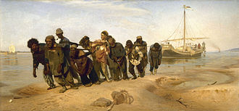

Ilya Repin “Barge Haulers on the Volga”

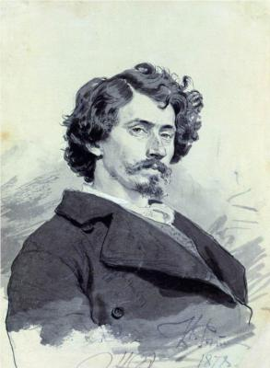 Ilya Repin was a talented Russian painter of the Peredvizhniki School, who was held up by the Soviet government as an artist to be imitated by the new school of Socialist Realists. At the age of 22, Repin began his art career at the Imperial Academy of Arts in St. Petersburg, the same time as the “Rebellion of the Fourteen,” when 14 young artists left the school after refusing to paint mythological paintings for their diplomas. These artists would later form the Society of the Peredvizhniki, which Repin joined in 1878. Repin and the free thinking “itinerants,” as they were also called, rebelled against the formal academy, insisting that art should reflect real life. As an art student, his travels took him to Italy, Paris and Impressionist Exhibitions, and although he was exposed to the vivid colors and quick brush strokes of the impressionist style, he remained true to his unique form of realism. Many of the subjects Repin painted were common people, like himself, although he did on many occasions paint the Russian elite, intelligentsia, and Tsar Nicholas II. He also painted many of his contemporary compatriots, including novelist Leo Tolstoy, composer Modest Mussorgsky, scientist Dmitri Mendeleev, and Ukranian painter Taras Schevchenko. A common recurring theme in his paintings was the Russian Revolutionary Movement, and as a result his works are often classified as a “Russian national style.” His first work “Barge Haulers on the Volga” brought him success. He was the author of the portrait of Stolypin. Repin was an honorary citizen of our city

**S s - "the sailor- artist".** Alexey Petrovich Bogolyubov was a Russian landscape painter. He called himself "the sailor- artist". He was a remarkable painter and not a wonderful person.

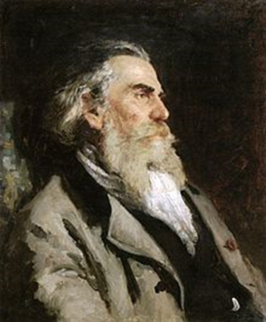

Bogolyubov was born in the Pomeranie village of Novgorodregion. His father was retired colonel Pyotr Gavriilovich Bogolyubov. Bogolyubov's grandfather was the well-known philosopher and social critic Alexander Radishchev.

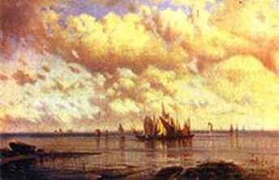 Sailing ships, 1860

In 1841 Alexey graduated from military school then served in the Russian Navy. He attended classes of the Saint Petersburg Academy of Arts, where he studied under Maxim Vorobiev. The young painter was greatly influenced by Ivan Ayvazovsky. In 1853, he finished the Academy with a Gold medal. From 1854 to 1860, he travelled around Europe where. In Europe he met Alexander Ivanov, took classes by the painter Andreas Achenbach. Bogolyubov returned to Russia in 1860. He exhibited his works in the Academy and received the title of professor. In the 1860s he traveled along the Volga. His paintings were full of the natural realism . In 1885, Bogolyubov founded an art museum in Saratov - the Radischev Art Museum, named it after his grandfather. It was opened seven years earlier than the Tretyakov Gallery in Moscow and fifteen years earlier than the Russian Museum in Saint Petersburg. Bogolyubov died on 3 February 1896 in Paris. After his death, Bogolyubov left all his money (about 200 thousand Russian rubles to the museum. After Bogolyubov's death the painting school was opened and named Bogolyubov's Painting School. Among painters who attended Bogolyubov's School were Victor Borisov-Musatov and Pavel Kuznetsov.

**Ss- “SARATOV SCHOOL”**

The artists of Saratov region played an important role in the development of art. In the early twentieth century there was so-called «Saratov school» of art. Its founder was Victor Borisov-Musatov. Among the members of it were P. Kuznetsov, P. Utkin, N. Krymov, N. Sapunov, S. Sudeikin, A. Arapov. They created the first group in Russia of Russian picturesque symbolism. In 1907 the artists organized the ezhibition “ Blue Rose” in Moscow which had a great success.

**Uu - The Union of Artists of Russia. Saratov regional organization**

Saratov regional public organization «Union of artists of Russia» was founded in 1939. There were 50 artists in it. В. Borisov-Musatov, P.V. Kuznetsov, K.S. Petrov-Vodkin, Utkin, A. I. Savinov, A.E. Karev, A. T. Matveev and others were the first members of this organization.

During the Second World War the artists produced Saratov sheets satire instilling confidence to citizens in Victory and strengthening the fighting spirit of them. In 70-90 years they developed the theme of the landscape - paintings and genre paintings. The artists took an active part in different exhibitions.

In 2006 - 2007 in the Saratov regional public Fund «Golden palette» held a competition for the best artists of the Volga Federal district which had a great success. Today the organization has 117 members: A. Uchaev, E. Vodonos, R. Batarshin, P. Maskaev, V. Shkunov and others. They are creative persons, they do not lose their faith in the high mission of art, and it helps them to create. The chairman of the organization is P.A. Maskaev.

Contacts: 137, Rakhov Street Saratov . Phone: (8452) 51-06-40К

**vv-** **Virtual Museum**

The Radishchev State Art Museum takes part in Russian project initiated by the Tretyakov Gallery that has won the competition Changing Museum in the Changing World held by Potanin Charitable Fund. The project is aimed to provide access to the Russian cultural heritage for millions of Internet users in our country and abroad. The Radishchev State Art Museum is a virtual branch of Russian Museum. The informational-educational center of it is a unique educational complex, using the modern computer technologies. I was opened in 2004 in Saratov. It organizes virtual tours and lectures for pupils and students. Training and educational activities of the informational-educational center is free of charge.

http://radmuseumart.ru/museum/structure/

**Ww- Watercolour painting**

Watercolour is a painting method. A watercolor is the medium or the resulting artwork. The traditional and most common support for watercolor paintings is paper; other supports include papyrus, bark papers, plastics, vellum or leather, fabric, wood, and canvas. Watercolors are usually transparent, and appear luminous because the pigments are laid down in a relatively pure form with few fillers obscuring the pigment colors. An artist working on a watercolor using a round brush. A lot of painters including Firs Zhuravlev, Petrov-Vodkin. Boris- Musatov, Bogolyubov used watercolour creating their pictures.

**Yy - Evgeni Yali**

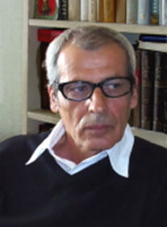 Evgeni Yaliis a Member of the Union of Artists of Russia. He is a well-known artist. His paintings can be seen in the Tretyakov State Art Gallery, in the Saratov State Art Gallery named after A.N. Radishchev, in the Saratov Regional Local Lore Museum, in the K.A. Fedin Museum, in the Museum of Local Studies located in Engels, in the Art Gallery in Volsk. In 1996 he was awarded by the Diploma for the best achievements in Fine Arts, in the Art of Criticism and Architecture. In April 1998 because of exemplary performance Evgeni Yali’s name was selected for biographical inclusion in the Eighth Edition of International Directory of Distinguished Leadership of the American Biographical Institute (North Carolina, USA).Now Evgeni Yali lives and paints in the City of Saratov, Russia**.**

**Zz – Firs Zhuravlev,**

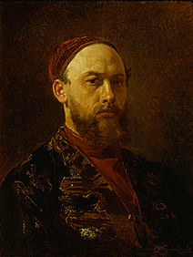 Firs Zhuravlev was born in 1836 in Saratov. He is famous as a genre painter and a portraitist. He studied at the Academy of Art in Moscow. He is known for his paintings of merchant life: „Merchant commemoration", „Before the crown" and others. His paintings are in the State Russian Museum in St. Petersburg, in the Tretyakov gallery and in the Radishchev Museum.

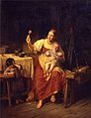 «Stepmother», (1874) the Radishchev Museum.