АНКЕТА
участника муниципального дистанционного конкурса по иностранным языкам «МОЗАИКА» для обучающихся муниципальных общеобразовательных учреждений
Татищевского муниципального района Саратовской области
в 2012 – 2013 учебном году

1. Фамилия, имя, отчество обучающегося (полностью)
_____________________________________________________________
2. Место учебы (образовательное учреждение)
_____________________________________________________________
3. Класс, год обучения
_____________________________________________________________
4. Изучаемый иностранный язык
_____________________________________________________________
5. Ф.И.О. учителя (полностью)
_____________________________________________________________
6. Контактные телефоны
_____________________________________________________________

ЗАДАНИЯ
What do you know about the Olympic Games?
1.Заполните таблицу
Boots, costume, pool ,ring, slope, skates ,skis, racket, stadium, rink, oar, rod, court, ball ,gloves, river, canal, hoop

sport | place | equipment
1)football
2)boxing
3)skiing
4) basketball
5) tennis
6) ice-skating
7) rowing
8) fishing
9) swimming

2. Напишите о каком виде спорта идет речь.
1)It is a game for two or four players who hit a ball with rackets across a net.
_____________________
2)It is a summer game played on a grass field by two teams with a ball, bats and wickets.
_____________________
3)It is a game played by two or four persons with a small hard ball which is struck with clubs into holes.
____________________
4)It is a team game played with oval ball.
_______________________

3. Вставьте слова и выражения в текст(впишите буквы)
The most popular sports in Russia.
Sports is very popular in Russia. More than 30 million people go to …(1)There are a lot of different sports that are very popular in Russia. One of them is football. According to official figures, nearly 5 million people go in for it. Almost each town has its own…(2). Ice hockey is one of the most popular among winter sports. Russian players have been taken part in …(3) since 1954 and have won the world title on many occasions. In 1988 we celebrated the hundredth anniversary of athletics. Track and field events are participated by 7.5 million people now. Russian sportsmen are the European, World and Olympic records holders in …(4). Other popular team…(5) are basketball and volleyball. More than 6 million people play volleyball in physical culture teams and sporting clubs. The men’s and women’s teams won Olympic, European and World Champion titles for many times.

a) sports centers
b) world championships
c) different disciplines
d) games
e) football team

4.Соедините английские и русские пословицы

1) A friend in need is a friend indeed  2) A bird in the hand is worth two in the bush  3)A man is known by the company he keeps  4)All is well that ends well  5)As like as two peas  6)Better late than never  7)East or West – home is best  8)Every man to his taste  9)Time is money  10)Slow and steady wins the race | a) Синица в руках лучше, чем журавль в небе.  b) Друзья познаются в беде.  c) Как две капли воды.  d) Время – деньги  e)На вкус и цвет – товарищей нет.  f)Скажи мне, кто твой друг, и я скажу тебе, кто ты.  g)В гостях хорошо, а дома лучше.  h) Добрый конец - всему делу венец.  i)Тише едешь, дальше будешь.  j) Лучше поздно, чем никогда

1 – 6 -
2 – 7 -
3 – 8 -
4 – 9 -
5 - 10 -

5.Вставьте в предложение нужный предлог
1) Since then they have been ….the Olympic prize winners for several times.
a) of; b)between; c) among
2) We are proud …. our sportsmen who win gold, silver and bronze medals.
a) at; b) by; c)of
3) The Russian team won a great number ….gold, silver and bronze medals.
a) of; b) off; c) with
4) What other events besides sport games are participated ….. a great number of people?
a) of; b) by; c) with

6. Прочитайте выдержку из газетной статьи. Подберите заголовок.

- Business News
- Political News
- Culture News
- Sports
- Fashion
- TV Guide

Текст
Russia's Alexei Yagudin is just one of the defending champions under pressure before this weeks world figure skating championships, which promise to be the most unpredictable in recent memory.
___________________________________________________________

7. Закончите предложение (впишите букву)
1)The ancient Olympic Games were held in Olympia, Greece from…
- the 8th century BC to the 4th century AD;
- the 7th century BC to the 5th century AD;
- the 9th century BC to the 4th century AD;
2) Baron Pierre de Coubertin founded the International Olympic Committee
(IOC) …..
a) in 1893.
b) in 1894.
c) in 1895.
3) The Olympic symbol is…
a) Olympic fire;
b) Olympic medal;
c) Olympic rings.
4) The colours of the Olympic rings are…
a) blue, yellow, black, green, and red;
b) blue, yellow, black, white and brown;
c) blue, yellow, black, green and grey
5) Russia first participated …
a) in the 1950 Summer Olympic Games;
b) in the 1951 Summer Olympic Games;
c) in the 1952 Summer Olympic Games;

8. Посмотрите на картинки и напишите на английском языке, какой вид спорта на них изображен
1) 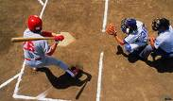2) 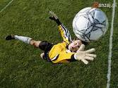

3) 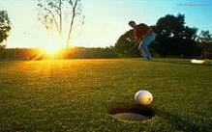4) 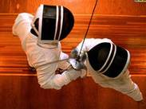

5) 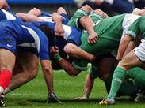6) 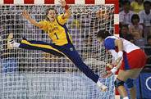 7) 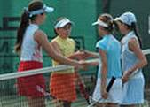

9. Соедините вопросы и ответы
1) Is this sportsman the best high jumper of the World Championship ?
2) What’s the matter with you, Mr. Brown?
3) What are your favourite sports?
4) How often do you go to a fitness club?

a) Oh, many of them.
b) Once a week
c) Certainly.
d) I don’t feel very well.

10. Соедините слова с противоположным значением
1) win a) slow
2) fast b) lose
3) strong c) stayer
4) sprinter d) weak

11. Напиши слова-ассоциации к картинкам (не менее 8 слов).
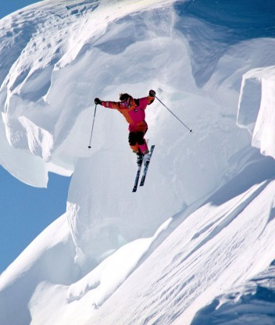

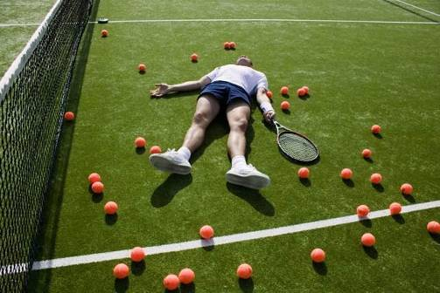

12. Составь рассказ к одной из картинок (10-15 предложений)

